Developed by Virus5600  
Twitter: [@SatchNavida](https://twitter.com/SatchNavida)  
Reddit: [u/SatchTFF](https://www.reddit.com/user/SatchTFF)  
Facebook: [Virus5600](http://www.facebook.com/virus5600)  
GitHub: [Virus5600](https://github.com/virus5600)  
Discord: [Defensive Measures Add-On](https://discord.com/invite/PCUKucADFr)  
Ko-Fi: [Virus5600](https://ko-fi.com/virus5600)

TABLE OF CONTENTS

**INTRODUCTION** . . . . . . . . . . . . . . . . . . . . . . . . . . . . . . . . . . . . 3  
 Description  
 Basic Information  
 Installation

**CONTENTS** . . . . . . . . . . . . . . . . . . . . . . . . . . . . . . . . . . . . . . . 5

Turrets . . . . . . . . . . . . . . . . . . . . . . . . . . . . . . . . . . . . 5

Cannon Turret

Ballista

MG Turret

Equipment . . . . . . . . . . . . . . . . . . . . . . . . . . . . . . . . . . . 8

Turret Remover

Blocks . . . . . . . . . . . . . . . . . . . . . . . . . . . . . . . . . . . . . 9

Arrowhead

Items . . . . . . . . . . . . . . . . . . . . . . . . . . . . . . . . . . . . . 10

Cannon Base

Cannon Stand

Unfinished Cannon Head

Cannon Head

Cannon Turret

Ballista Base

Ballista Base with Stand

Arrowhead

Ballista Arrow

Ballista Bow

Ballista Turret

MG Base

MG Stand

Ammo Case

Ammo Rounds

MG Head

MG Turret

**INTRODUCTION**

**Description:**

Defensive Add-on is an add-on that allows players to place defensive turrets and traps to protect themselves, their creations, positions, and so on. The add-on adds ***Towers***, ***Traps***, ***Entities***, ***Structures***, ***Villager Types***, and ***Items*** to the game, which opens a lot of new capabilities, ideas, and creative imaginations for the players to explore.

**Basic Information:**

Author: Satch Navida (Virus5600)  
Minimum Required Game Version: 1.19.2  
Add-on Version: 1.0.0  
Dependencies: Defensive Measures (RP)  
Compatible with: Majority of add-ons.

**Installation:**

To install the Add-on, please follow the instructions provided below:

**<WINDOWS 10>**

1. **Extract** the contents of the archive.
2. **Double click** the mcpack.
3. Open Minecraft and create a new world.
4. Enable the **“Holiday Creator Features”**.
5. Generate the world.
6. Enjoy!

**<MOBILE>**

1. **Extract** the contents of the archive.
2. Move the **Behavior Pack** **(BP)** archive to “games/com.mojang/behavior_packs”.
3. Move the **Resource Pack (RP)** archive to “games/com.mojang/resource_packs”.
4. Open Minecraft and create a new world.
5. Enable the **“Holiday Creator Features”**.
6. Generate the world.
7. Enjoy!

**CONTENTS**

**Turrets:**

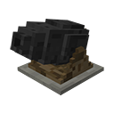**Cannon Turret** - The very first turret implemented in the add-on. It shoots cannonballs that explodes upon impact.

Damage: 15 (C:\Users\karls\AppData\Local\Microsoft\Windows\INetCache\Content.Word\heart icon (full).png * 7 + heart icon (half) * 1)  
Range: 16 blocks  
Attack Speed: 0.2 shots/s  
Is AoE: YES  
Health: 50 (C:\Users\karls\AppData\Local\Microsoft\Windows\INetCache\Content.Word\heart icon (full).png * 25)  
Repairable: YES  
Repair Items:  
 > Wood Planks: +1 ( * 1)  
 > Iron Nugget: +1 (C:\Users\karls\AppData\Local\Microsoft\Windows\INetCache\Content.Word\heart icon (half).png * 1)  
 > Iron Ingot: +10 (C:\Users\karls\AppData\Local\Microsoft\Windows\INetCache\Content.Word\heart icon (full).png * 5)  
 > Iron Block: +100 (C:\Users\karls\AppData\Local\Microsoft\Windows\INetCache\Content.Word\heart icon (full).png * 50) & Absorption 3/+6 ( * 3)



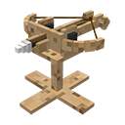**Ballista** - One of the cheapest turrets to build in the add-on. It shoots arrows that deals low damages to enemy.

Damage: 1-4 (heart icon (half) * 1 TO C:\Users\karls\AppData\Local\Microsoft\Windows\INetCache\Content.Word\heart icon (full).png * 2)  
Range: 16 blocks  
Attack Speed: 0.5 shots/s  
Is AOE: YES  
Health: 25 (heart icon (half) * 1 + C:\Users\karls\AppData\Local\Microsoft\Windows\INetCache\Content.Word\heart icon (full).png * 11)  
Repairable: YES  
Repair Items:  
 > Stick: +1(heart icon (half) * 1)  
 > String: +1 (heart icon (half) * 1)  
 > Wood Planks: +3 (heart icon (half) * 1 +  * 1)  
 > Wood: +15 (heart icon (half) * 1 +  * 7)

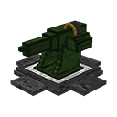**MG Turret** - The MG Turret is the first modern turret in the Add-On. It shoots a barrage of bullets that deals relatively high damage.

Damage: 5-10 (heart icon (half) * 1 + C:\Users\karls\AppData\Local\Microsoft\Windows\INetCache\Content.Word\heart icon (full).png * 2 TO C:\Users\karls\AppData\Local\Microsoft\Windows\INetCache\Content.Word\heart icon (full).png * 5)  
Range: 16 blocks  
Attack Speed: 1 shots/s  
Is AOE: NO  
Health: 75 (heart icon (half) * 1 + C:\Users\karls\AppData\Local\Microsoft\Windows\INetCache\Content.Word\heart icon (full).png * 37)  
Repairable: YES  
Repair Items:  
 > Iron Nugget: +1(heart icon (half) * 1)  
 > Iron Ingot: +10 ( * 5)  
 > Iron Block: +100 (C:\Users\karls\AppData\Local\Microsoft\Windows\INetCache\Content.Word\heart icon (full).png * 50) & Absorption 3/+6 ( * 3)

**Equipment:**

**Turret Remover** - Let’s you remove an already placed turret. Not really useful for whacking hostile mobs now, is it?

Weapon: NO

Durability: 100

Repairable: YES

Repair Items:

> Gold Nugget: +2 durability

> Iron Nugget: +2 durability

> Gold Ingot: +20 durability

> Iron Ingot: +20 durability

> Redstone: +20 durability

> Redstone Block: +100 durability

**Blocks:**

**Arrowhead** - The first ever block and trap the add-on has to offer! Small damage but cheap to produce!

Damage: 2 (C:\Users\karls\AppData\Local\Microsoft\Windows\INetCache\Content.Word\heart icon (full).png * 2)/step

Durability: N/A

Upgradable: NO

Reusable: YES

Mob Effects: NONE

**Items:**

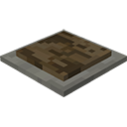**Cannon Base -** The base of the Cannon Turret. Sturdy enough to hold a cannon down and support a rain of artillery.

**Recipe**

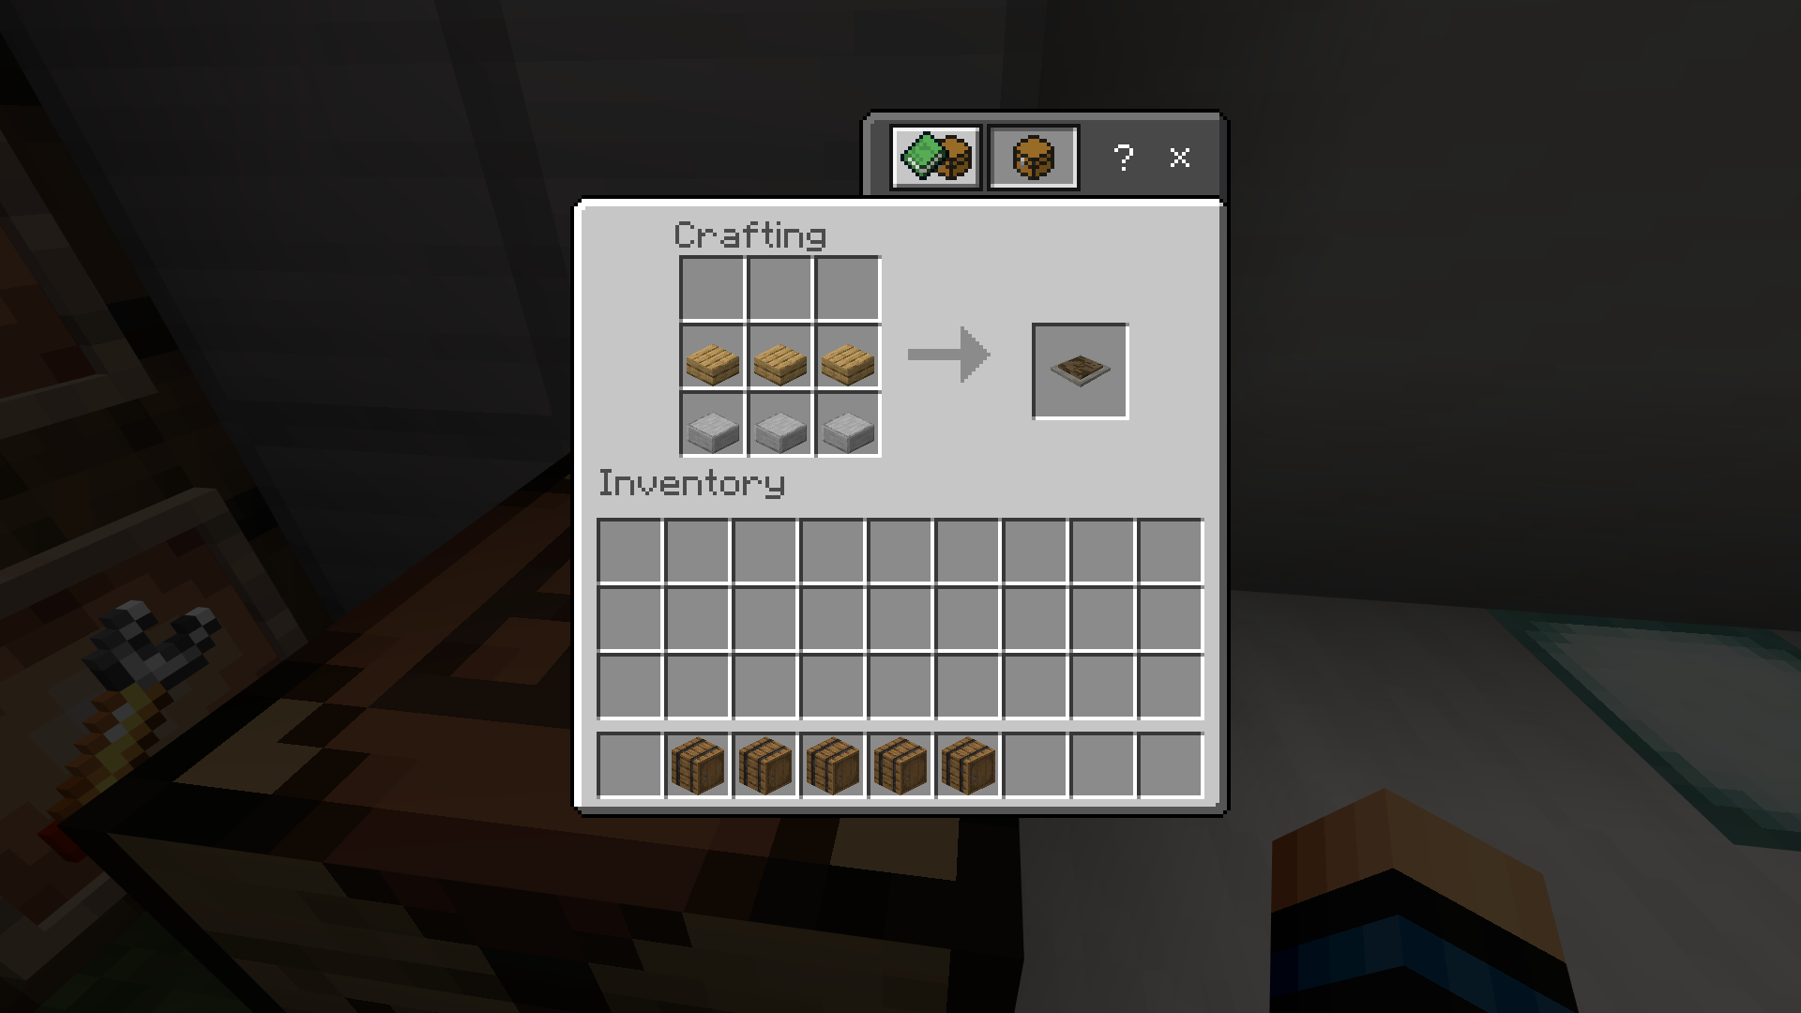

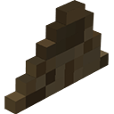**Cannon Stand** - Provides the yaw needed by the Cannon Head to aim and shoot enemies.

**Recipe**

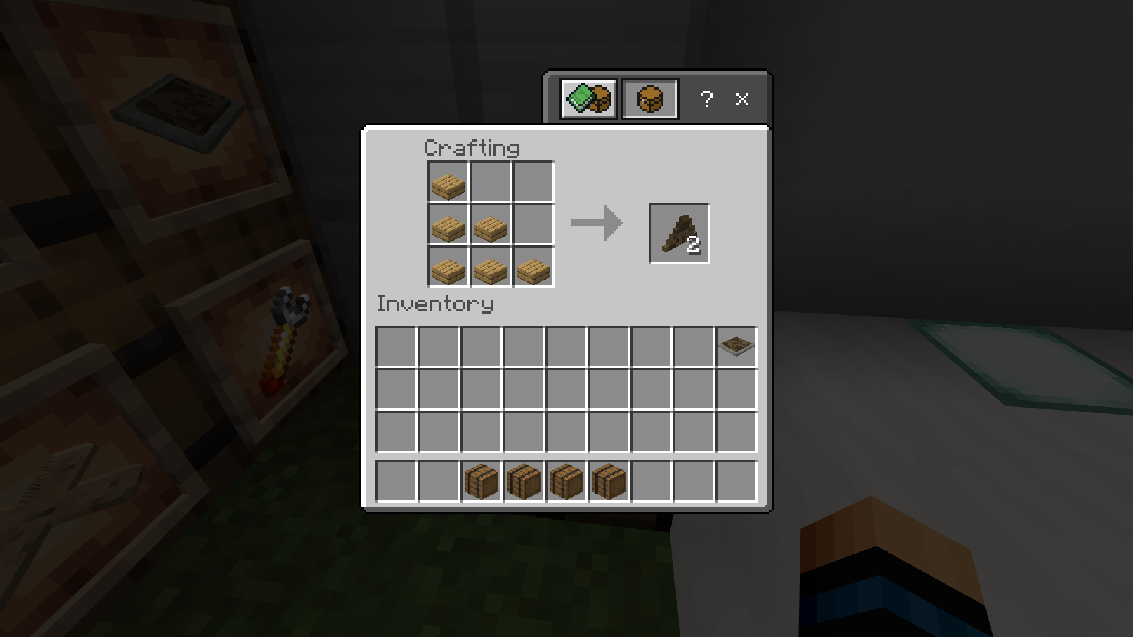

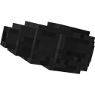**Unfinished Cannon Head** - The product of casting iron into a barrel, capable of launching explosive cannonballs and devastate enemies. Don’t forget the fuse!

**Recipe**

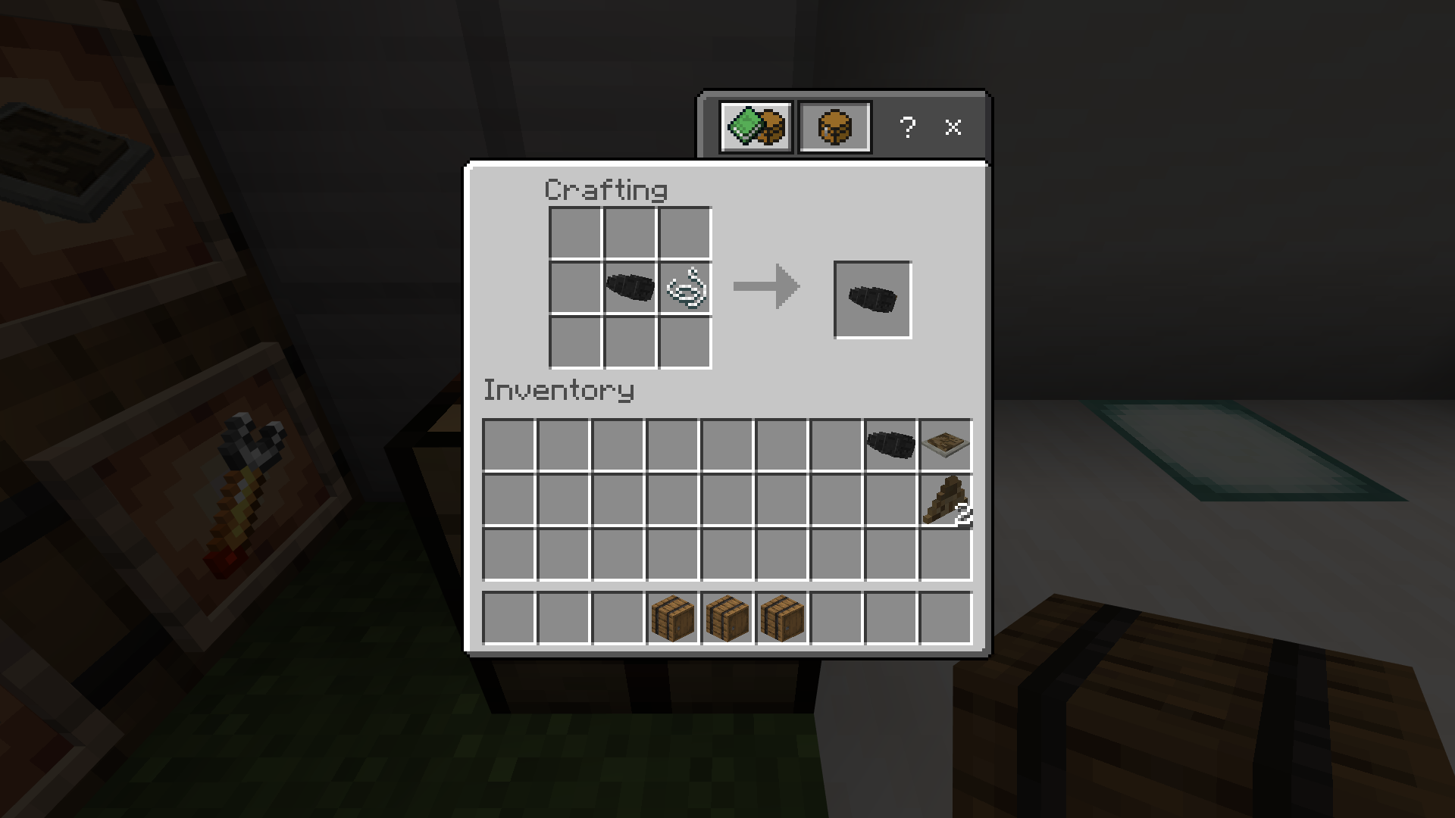

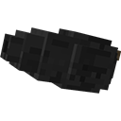**Cannon Head** - With the fuse added, the cannon can now shoot… but it needs its base and stand to hold it in place.

**Recipe**



**Cannon Turret** - Cannon turrets can shoot explosive cannonball that deals massive AoE damage and knocks enemies back. Slow RoF so supplement it with some other turrets or defenses.

**Recipes**

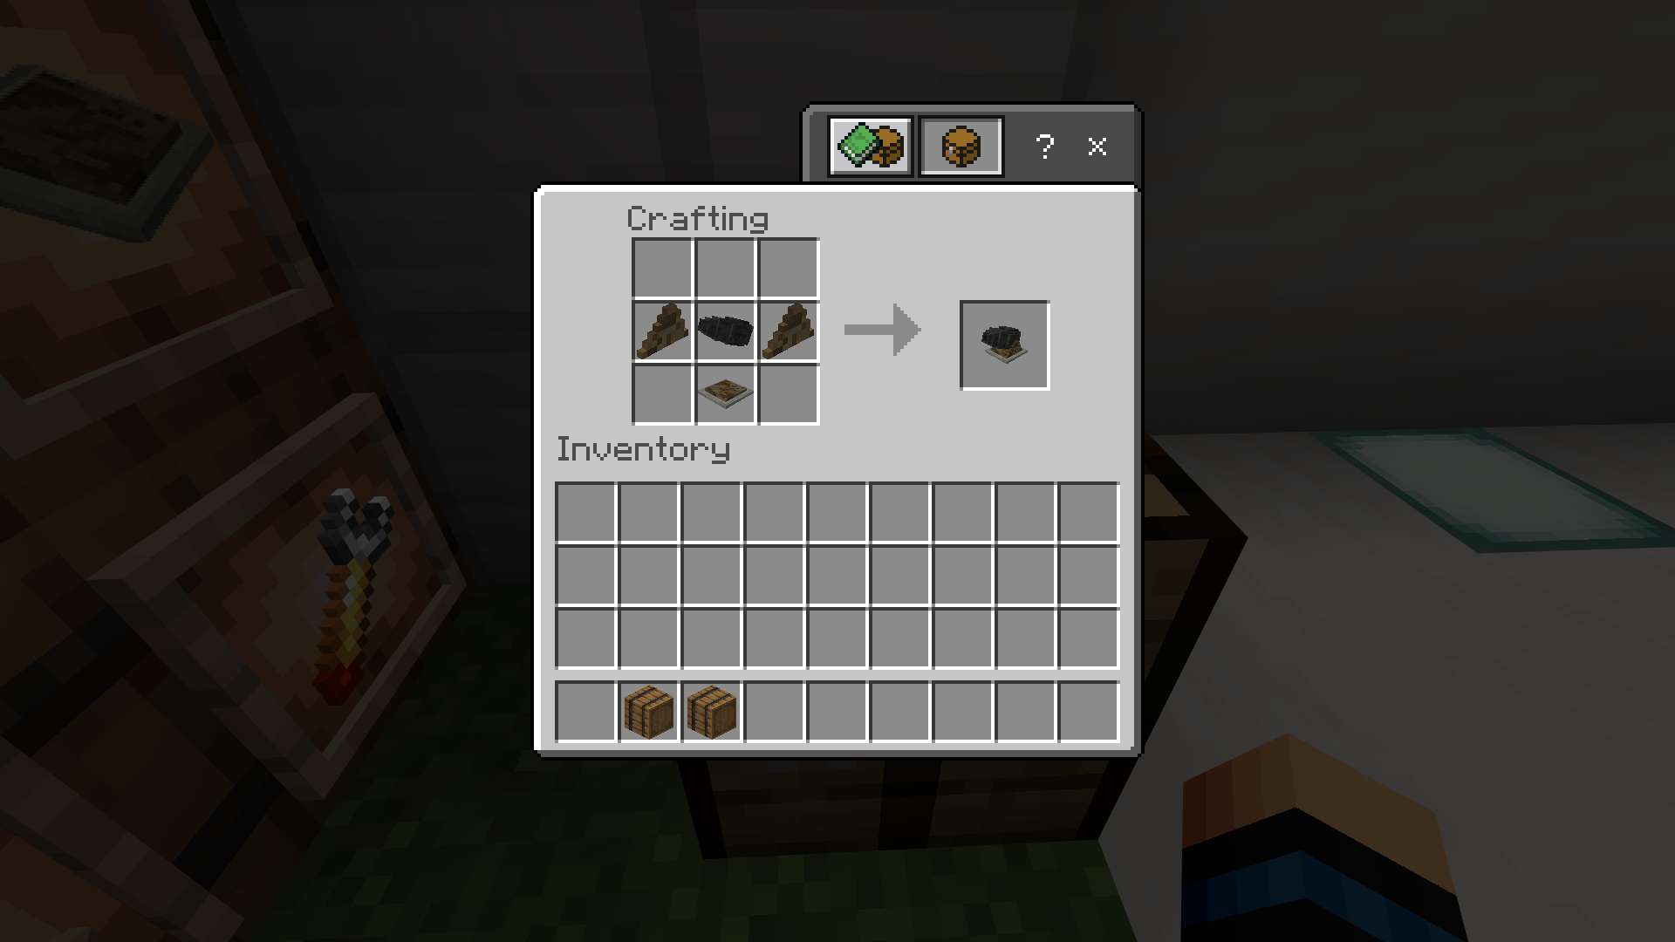

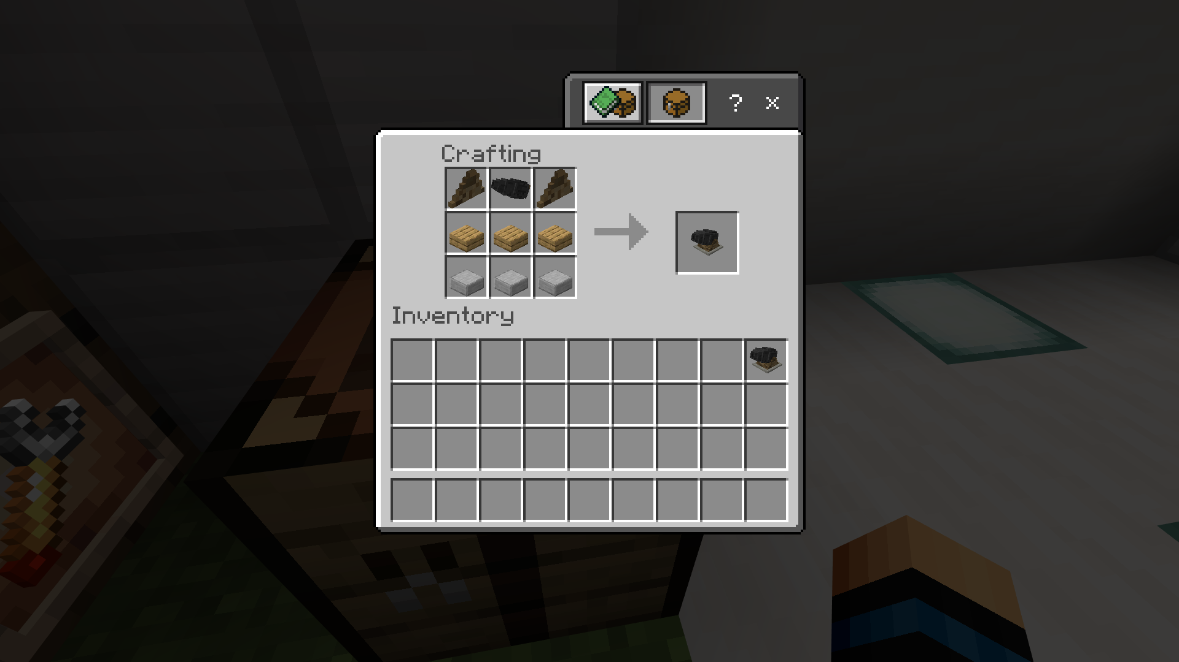

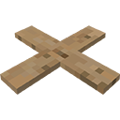**Ballista Base** - The base of the Ballista that will help it keep in place. Cheap and reliable!

**Recipe**

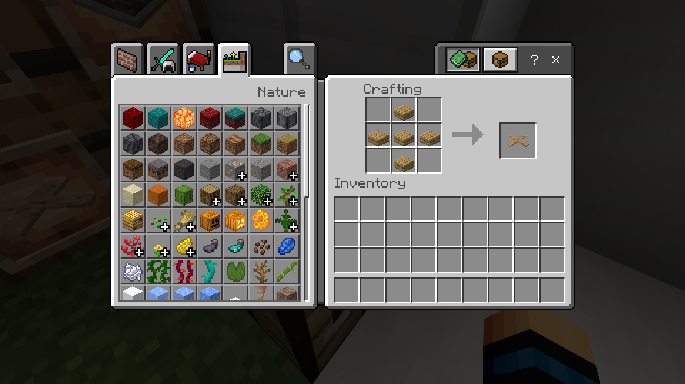

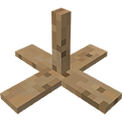**Ballista Base with Stand** - The same old cheap base, now with the stand attach!

**Recipe**

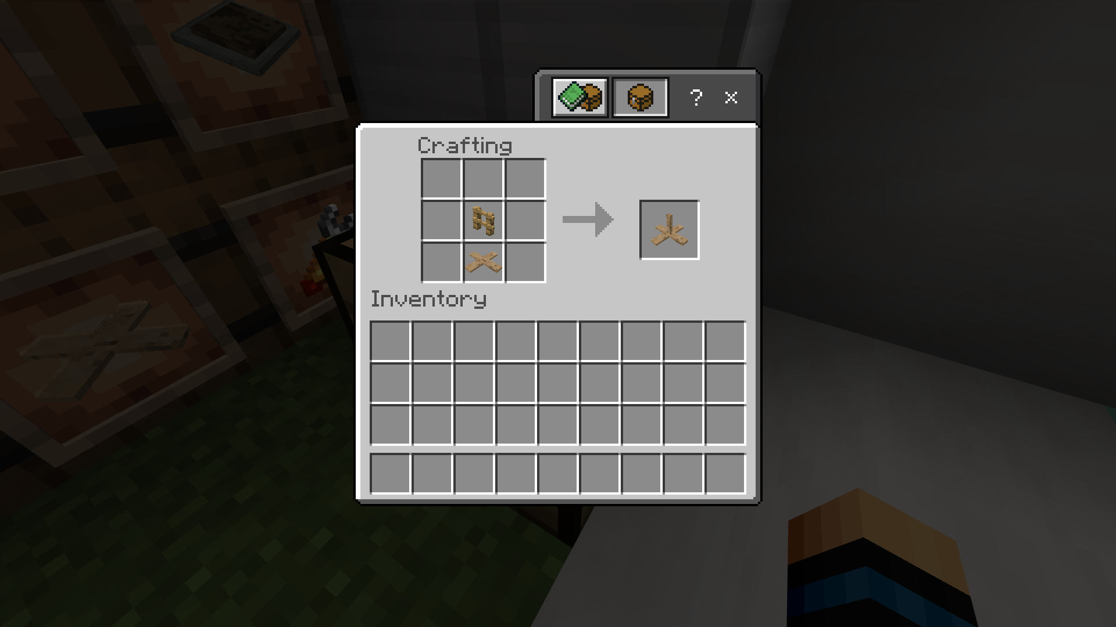

**Arrowhead** – The tip of the Ballista Arrow. Can be used as a simple and cheap trap for unsuspecting mobs.

**Recipe**

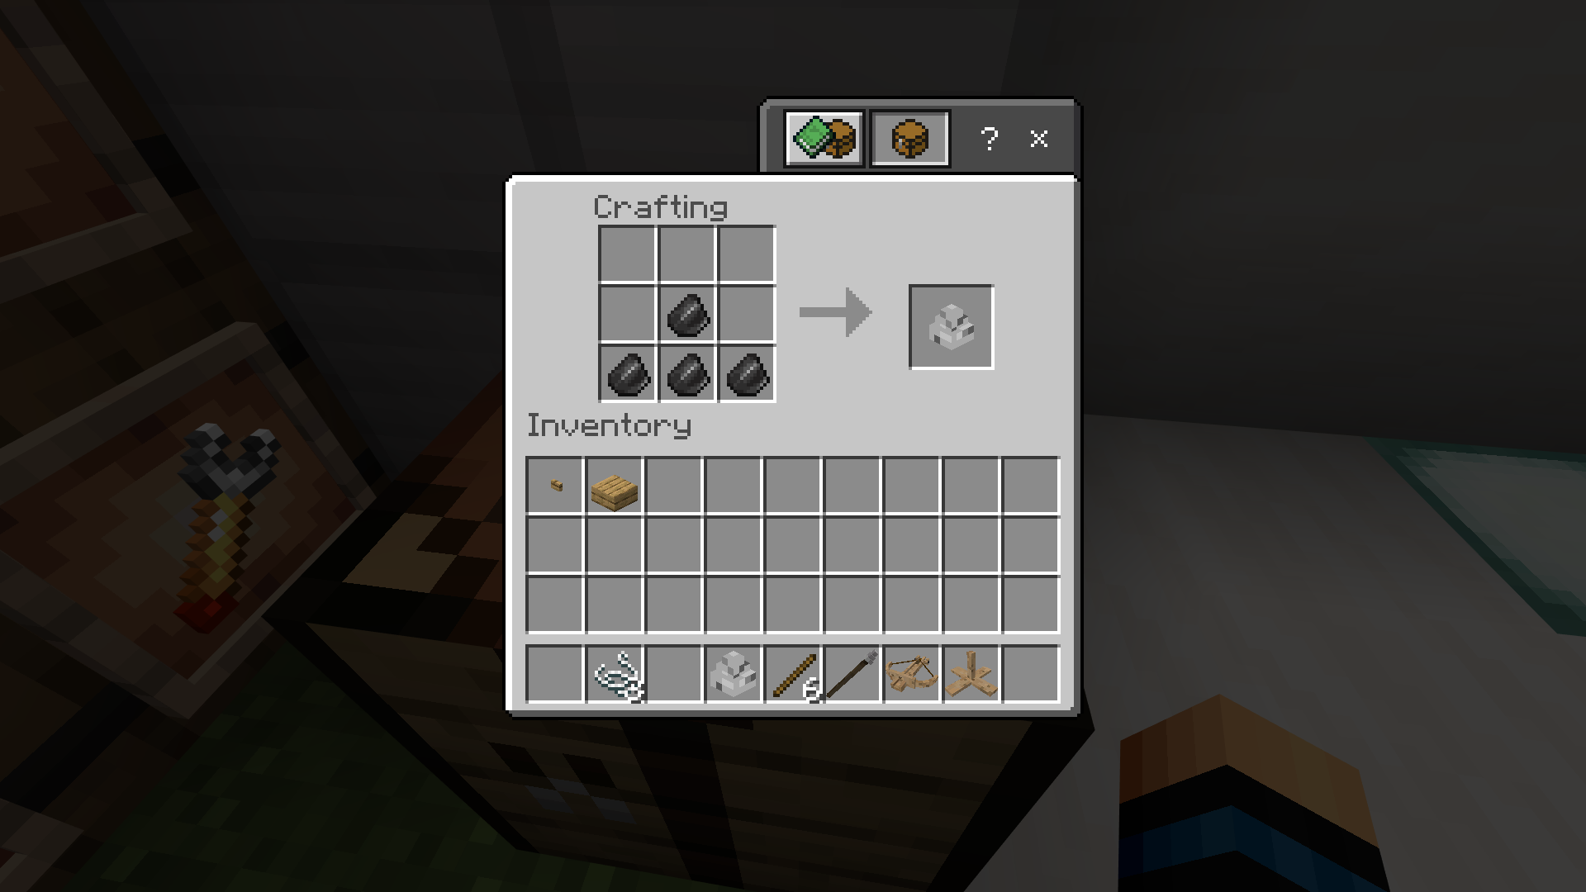

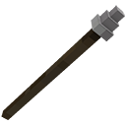**Ballista Arrow** – The ammo used by the Ballista for attacking. Better not forget it or the Ballista won’t shoot.

**Recipe**

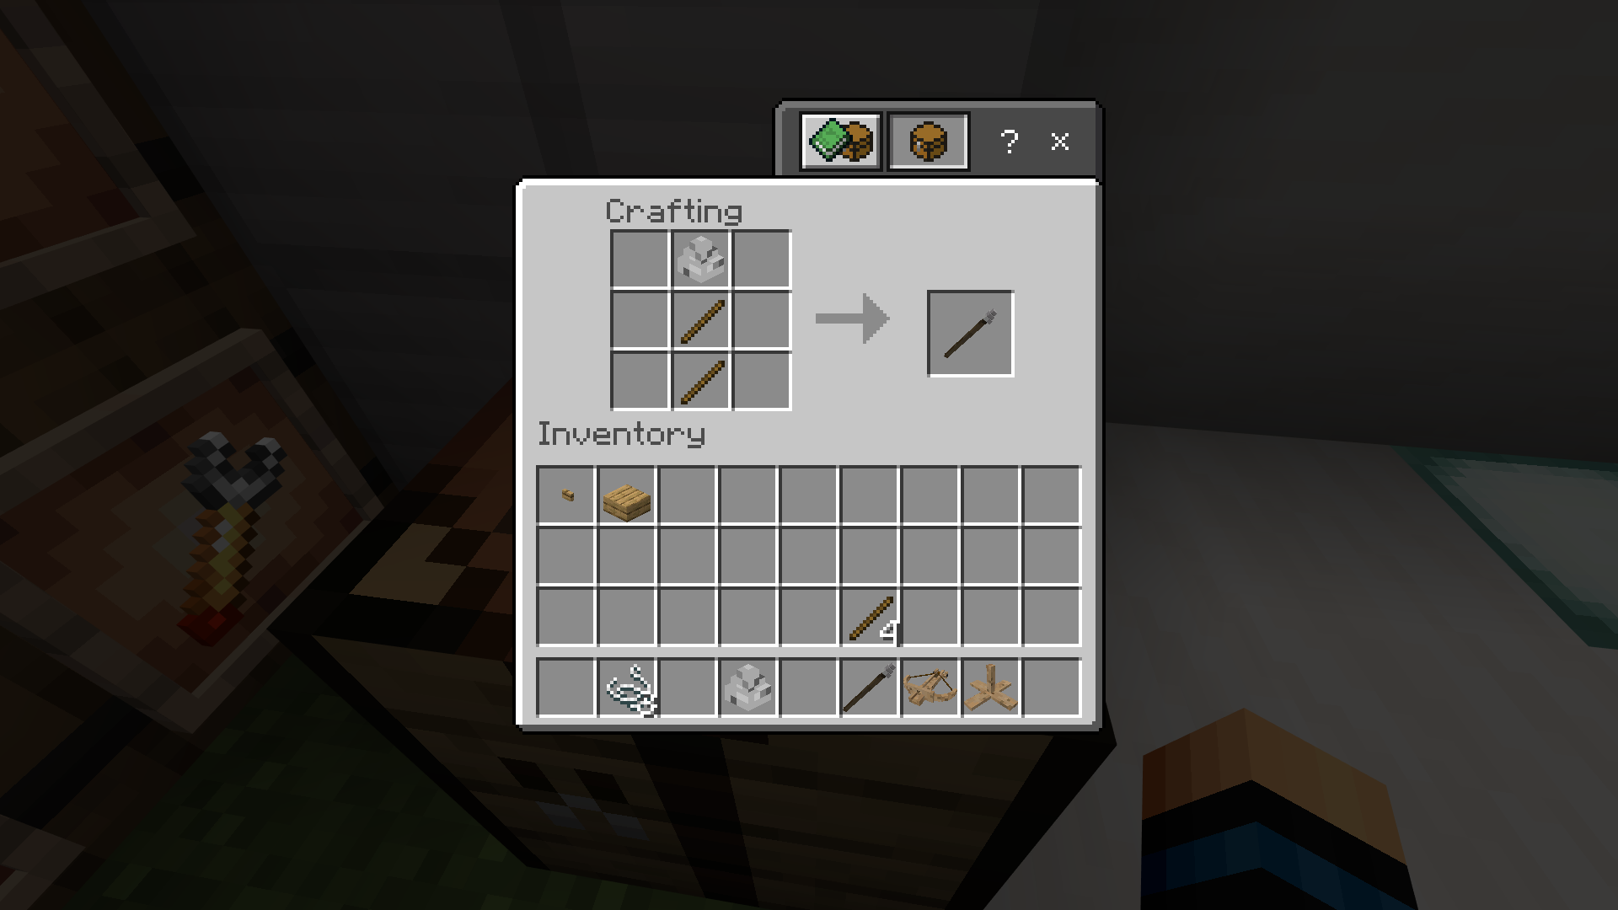

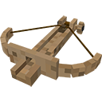**Ballista Bow** - The Ballista Bow presents the head of the turret. This is where the Ballista Arrow is loaded for attacking.

**Recipe**

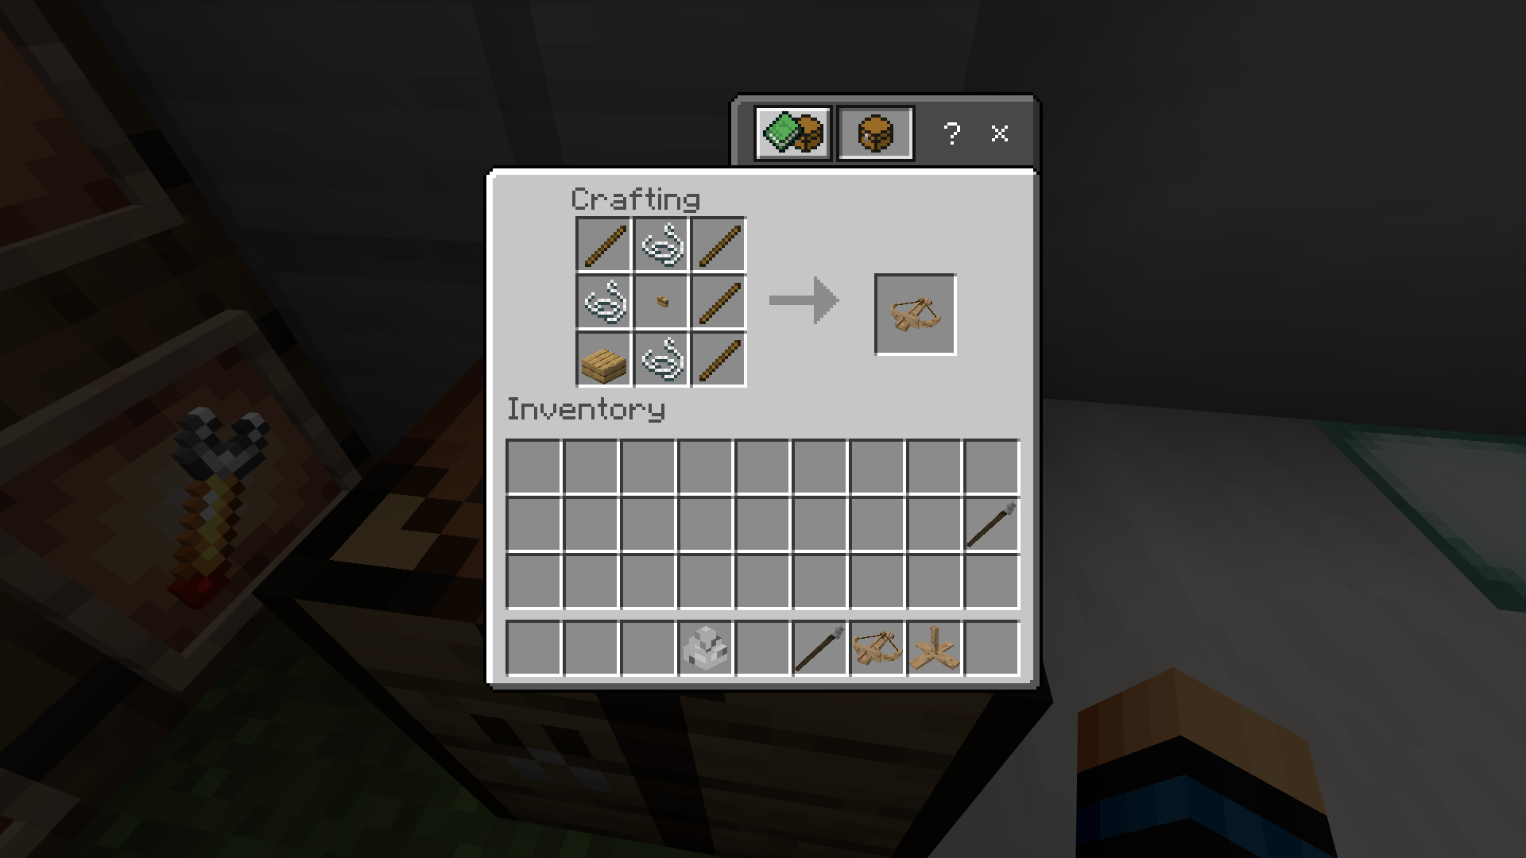

**Ballista Turret** - The culmination of the entire wood cutting has finally paid off! A cheap but reliable turret for defensive measures! Fits even medieval themed world!

**Recipe**

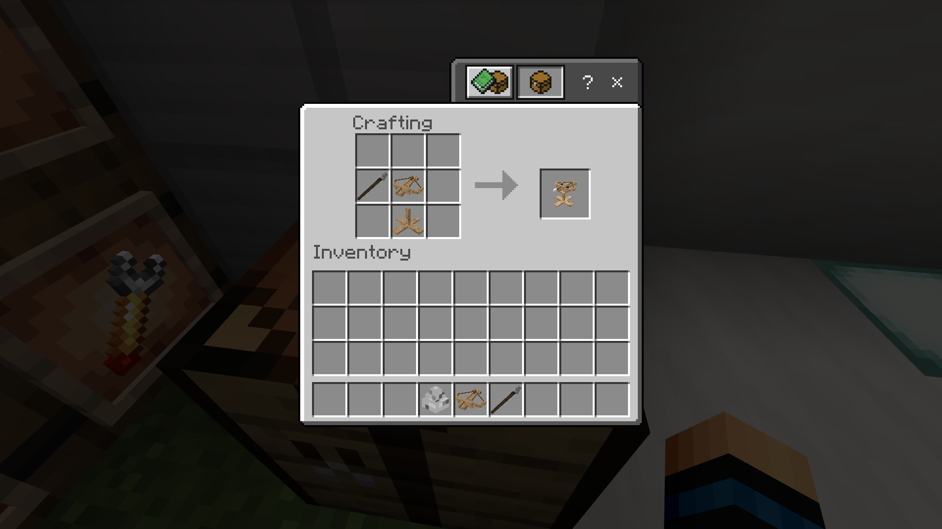

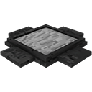**MG Base** - A sturdy base for a sturdy turret. Must really be heavy or else, the recoil might send the turret off.

**Recipe**

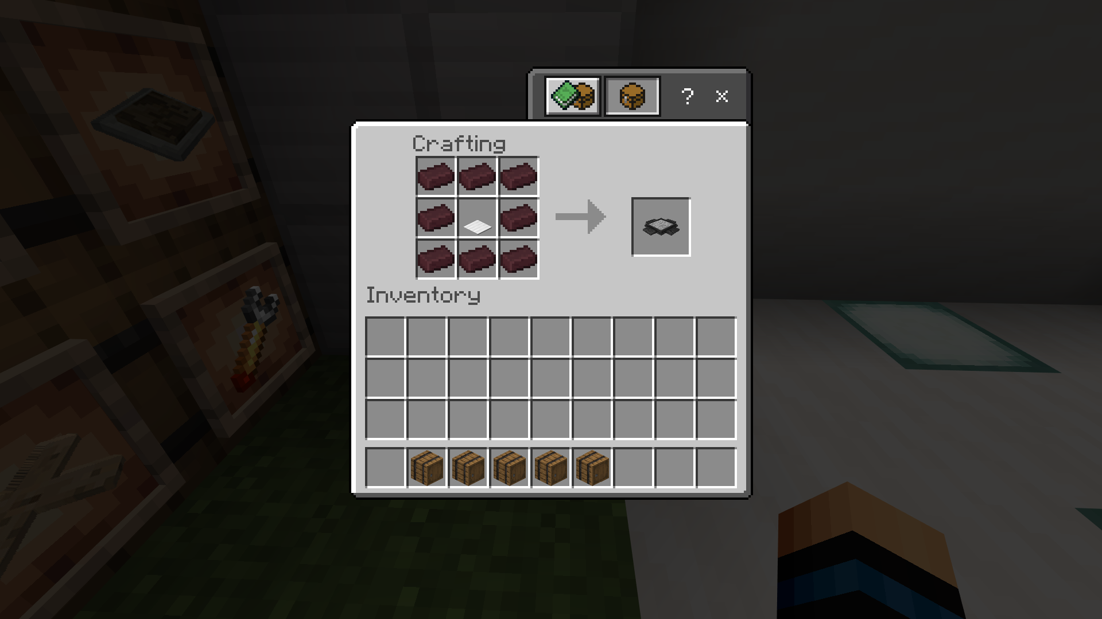

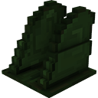**MG Stand** - The stand allows the head to rotate horizontally and vertically. Sturdy and will definitely hold the gun on place while shooting!

**Recipe**

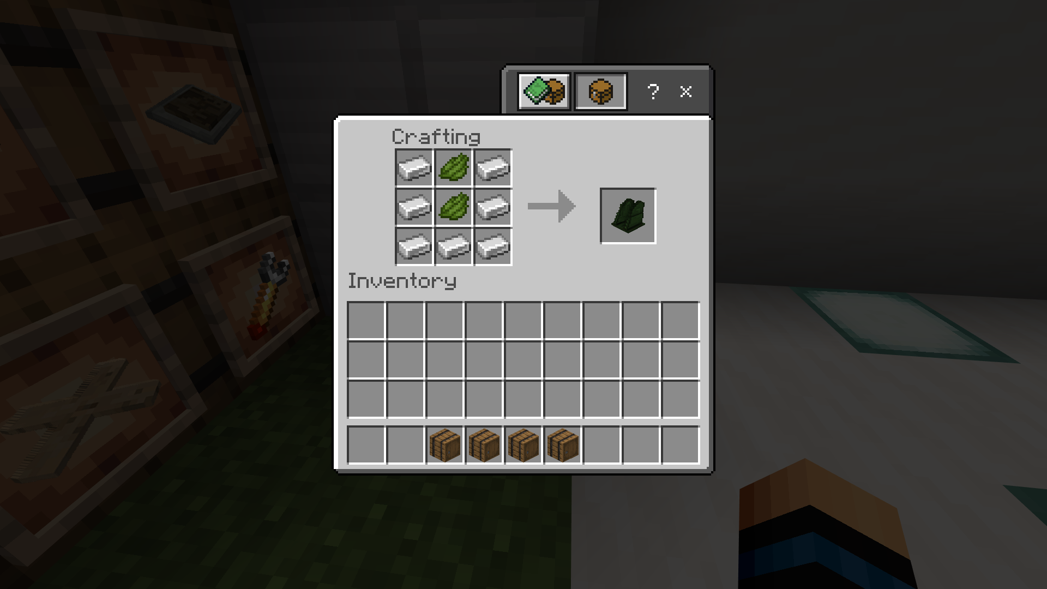

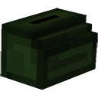**Ammo Case** - Holds all the ammo that the machine gun will hold. I wonder how it feeds itself after depleting all the ammo inside.

**Recipe**

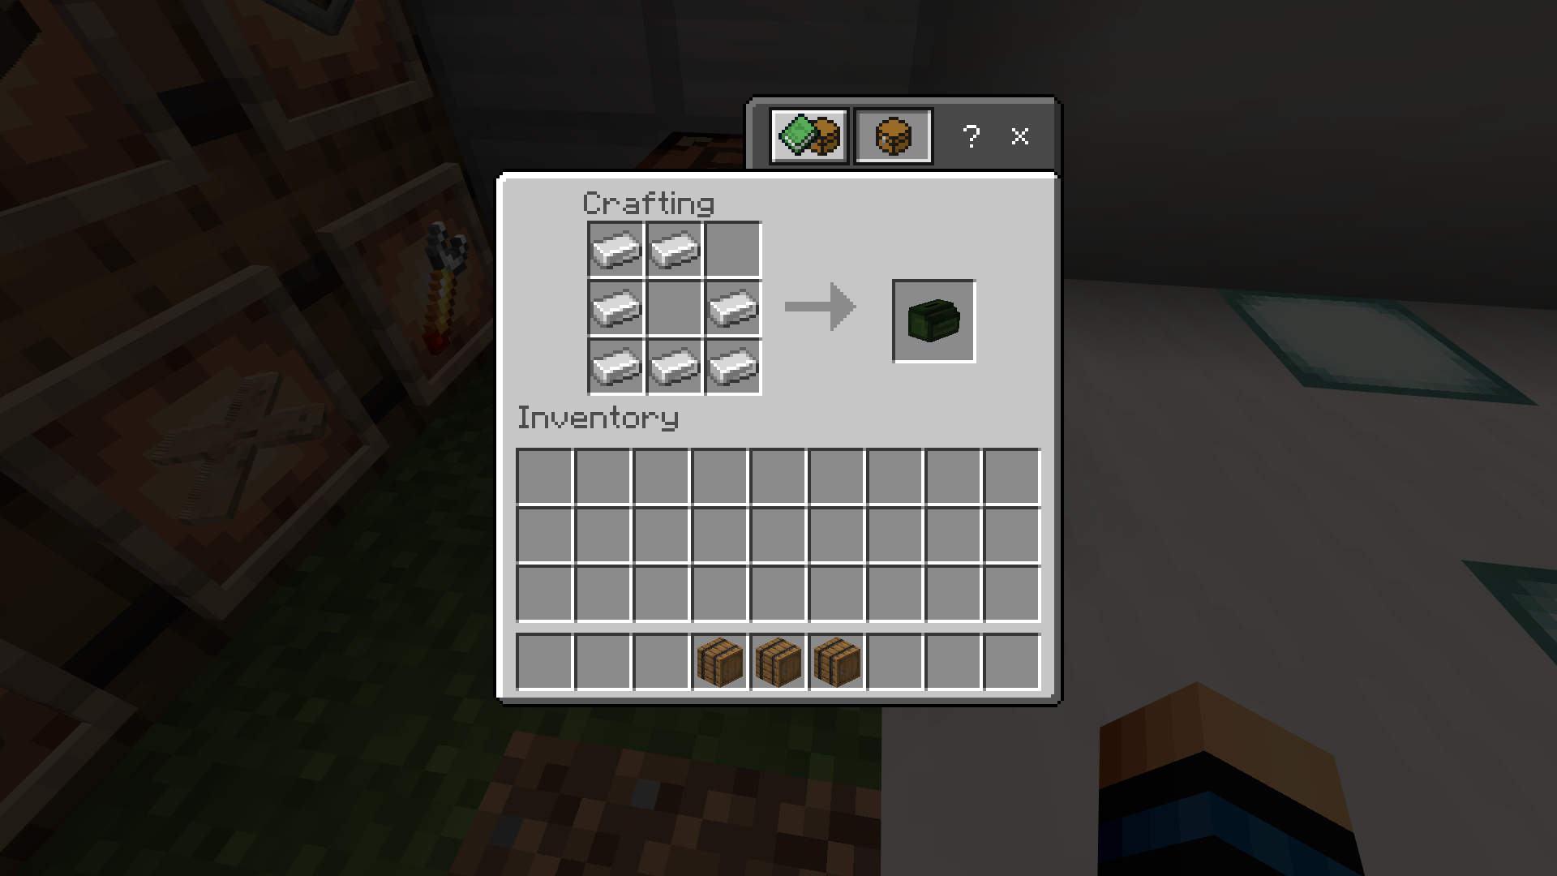

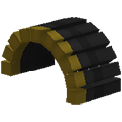**Ammo Rounds** - The ammo rounds containing all the bullets that the turret will shoot. Surprisingly cheap for an infinite number of bullets, isn’t?

**Recipe**

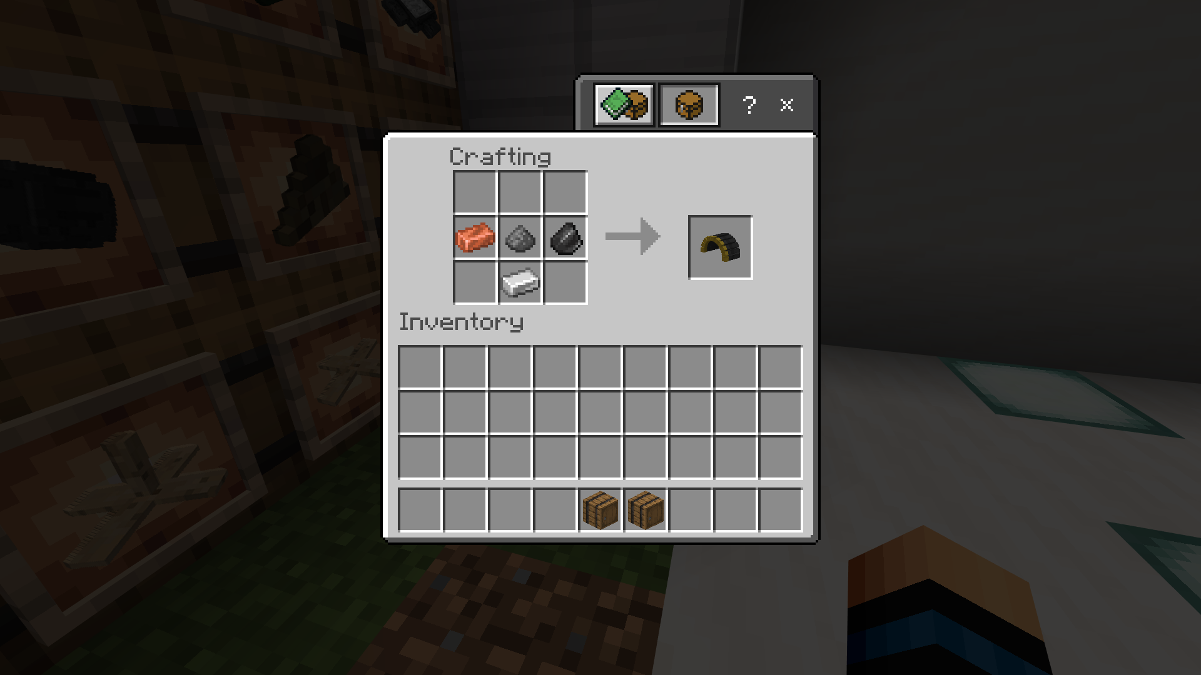

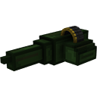**MG Head** - The head of the turret, composed of the Ammo Rounds, Ammo Case, and the gun itself.

**Recipe**

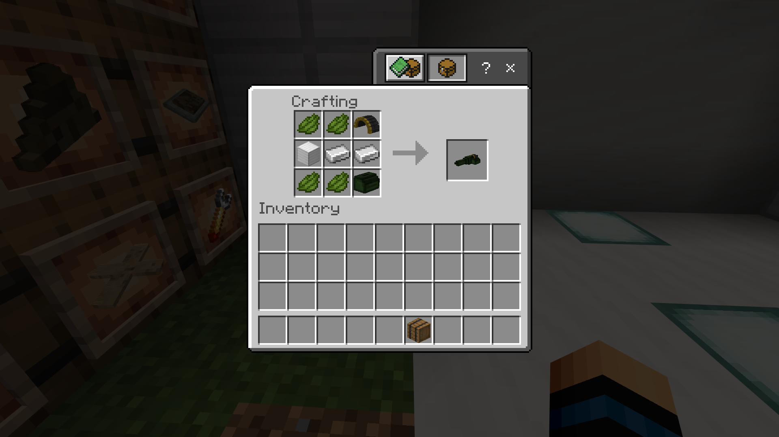

**MG Turret** - The final culmination of mining irons, smelting them with netheracks, and finding green dyes. This will allow you to place an MG Turret that fires 10 bursts of bullets at the enemies.

**Recipe**

